**Use Dashboard Nodes for Creating UI (Web Apps)**

|  |  |
| --- | --- |
| Team ID | PNT2022TMID05942 |
| Project Name | Smart waste management system for metropolitan cities |

# Step 1: Open Node red and pick and place blocks according to python script flow Step2: Make sure necessary blocks are installed in Node Red Step 3: After creating the flow click on deploy Step 4: Output is displayed in Node-red Debug window Step 5: Also, web UI can also be seen by the URL followed by/ui

**Screenshots: NODE – RED FLOW**

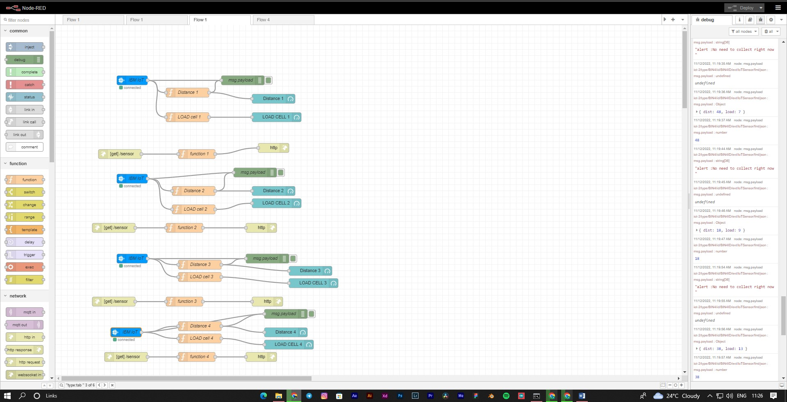

**NODE – RED UI**

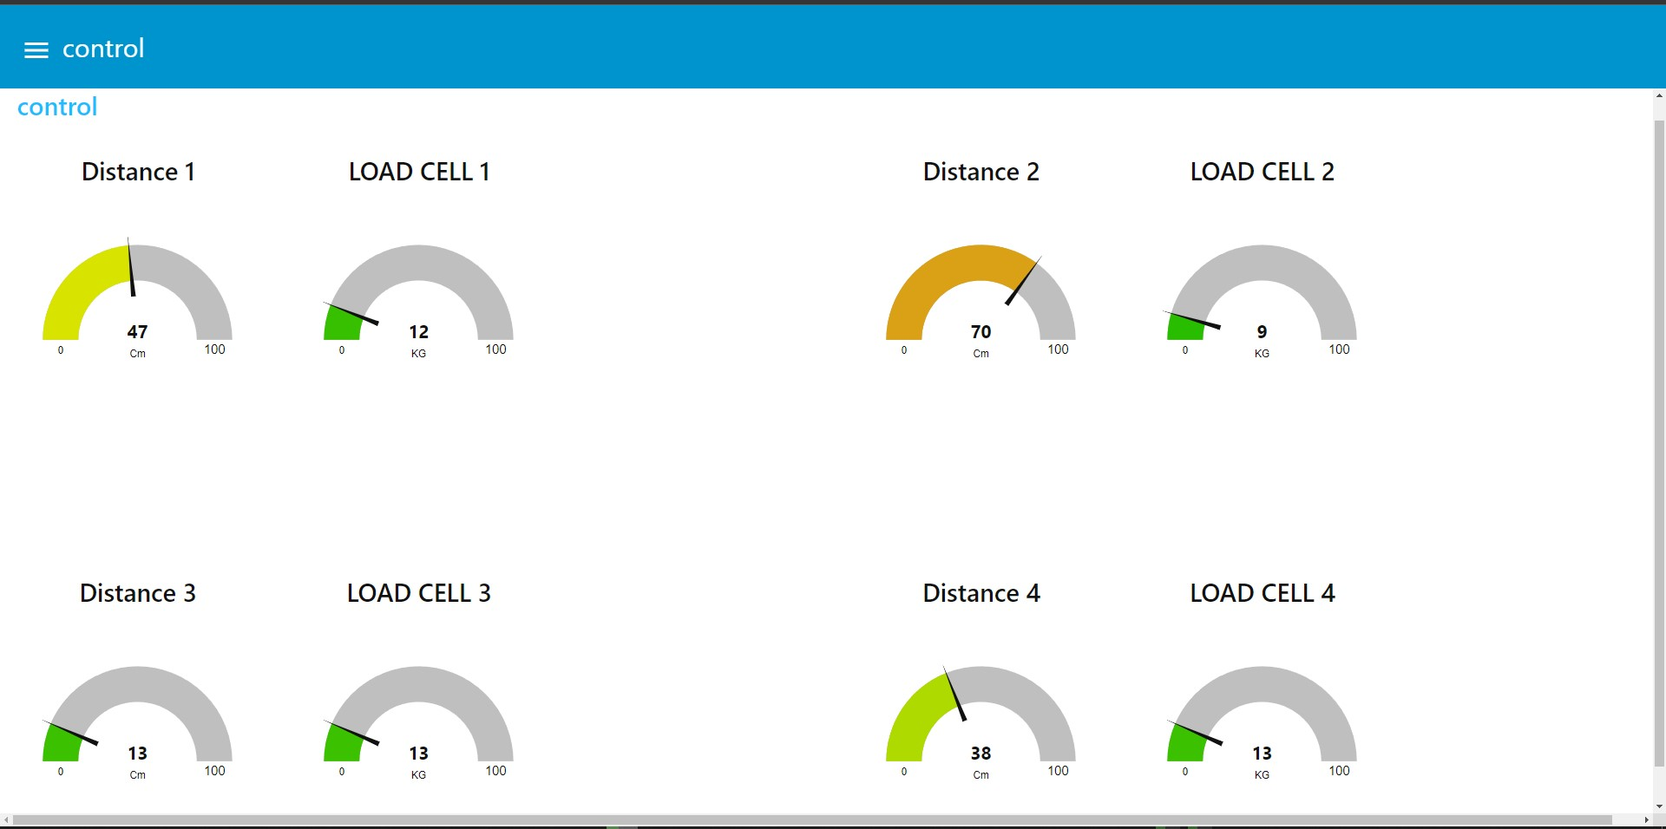

**Code Flow :**

|  |
| --- |
| [ |
|  | { |
|  | "id": "147146a0342debce", |
|  | "type": "ibmiot in", |
|  | "z": "6ed1189c17ed0439", |
|  | "authentication": "apiKey", |
|  | "apiKey": "bf9996433728395e", |
|  | "inputType": "evt", |
|  | "logicalInterface": "", |
|  | "ruleId": "", |
|  | "deviceId": "BIN4ID", |
|  | "applicationId": "", |
|  | "deviceType": "BIN4", |
|  | "eventType": "+", |
|  | "commandType": "", |
|  | "format": "json", |
|  | "name": "IBM IoT", |
|  | "service": "registered", |
|  | "allDevices": "", |
|  | "allApplications": "", |
|  | "allDeviceTypes": false, |
|  | "allLogicalInterfaces": "", |
|  | "allEvents": true, |
|  | "allCommands": "", |
|  | "allFormats": "", |
|  | "qos": 0, |
|  | "x": 230, |
|  | "y": 1000, |
|  | "wires": [ |
|  | [ |
|  | "71be31afc89560dd", |
|  | "a0cbff62cdd2e77c", |
|  | "c49cd92e337f886b" |
|  | ] |
|  | ] |
|  | }, |
|  | { |
|  | "id": "bf9996433728395e", |
|  | "type": "ibmiot", |
|  | "name": "Gogul", |
|  | "keepalive": "60", |
|  | "serverName": "", |
|  | "cleansession": true, |
|  | "appId": "", |
|  | "shared": false |
|  | } |
|  | ] |